LAB 7

JSON ASSIGNMENT

Athul u c

211047022

What is JSON?

• JSON stands for JavaScript Object Notation

• JSON is a lightweight data-interchange format

• JSON is plain text written in JavaScript object notation

• The filename extension is. json.

**1.Encode:**

package athu;

import org.json.simple.JSONArray;

import org.json.simple.JSONObject;

import java.io.FileWriter;

import java.io.IOException;

public class JsonEncodeDemo {

public static void main(String[] args) {

JSONObject obj = new JSONObject();

obj.put("Name","Athul u c");

obj.put("number",new Integer(999));

obj.put("balance",new Double(105555.43));

obj.put("salary",new Double(10500.98));

obj.put("is_intern",new Boolean(true));

try (FileWriter file = new FileWriter("E:\\test.json")) {

file.write(obj.toJSONString());

System.out.println("Succesfully written Json to File");

}

catch (IOException e) {

e.printStackTrace();

}

System.out.print(obj);

}

}

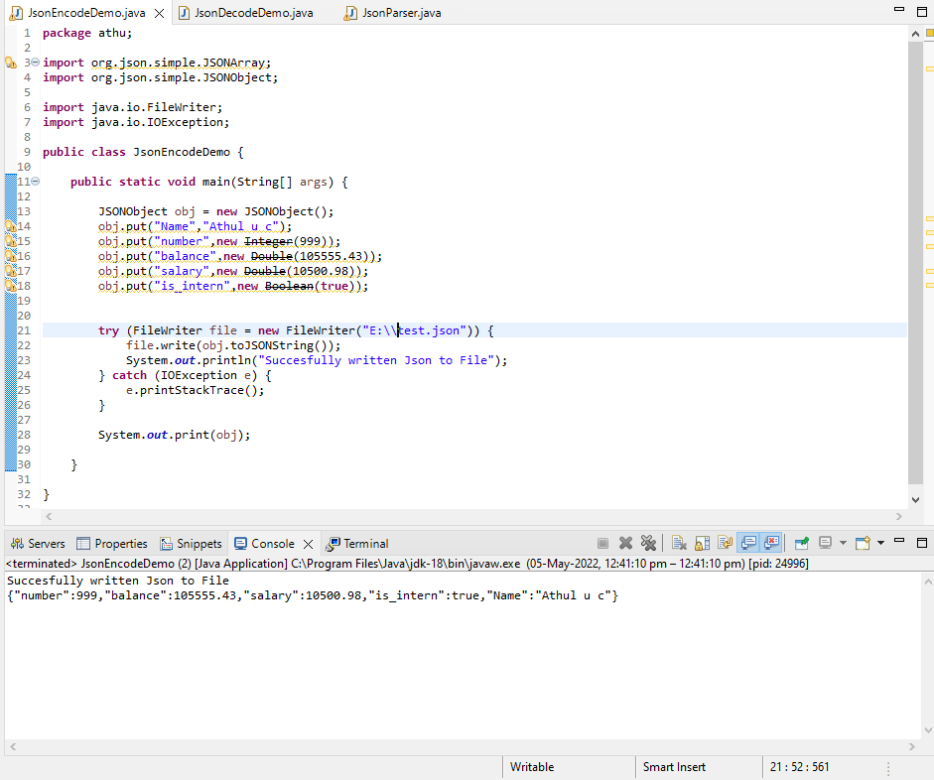

**2.Decode:**

**package** athu;

**import** org.json.simple.JSONObject;

**import** org.json.simple.JSONArray;

**import** org.json.simple.parser.ParseException;

**import** org.json.simple.parser.JSONParser;

**public** **class** JsonDecodeDemo {

**public** **static** **void** main(String[] args) {

JSONParser parser = **new** JSONParser();

String s = "[0,{\"1\":{\"2\":{\"3\":{\"4\":[5,{\"6\":7}]}}}}]";

**try**{

Object obj = parser.parse(s);

JSONArray array = (JSONArray)obj;

System.***out***.println("The 2nd element of array");

System.***out***.println(array.get(1));

System.***out***.println();

JSONObject obj2 = (JSONObject)array.get(1);

System.***out***.println("Field \"1\"");

System.***out***.println(obj2.get("1"));

s = "{}";

obj = parser.parse(s);

System.***out***.println(obj);

s = "[5,]";

obj = parser.parse(s);

System.***out***.println(obj);

s = "[5,,2]";

obj = parser.parse(s);

System.***out***.println(obj);

}**catch**(ParseException pe) {

System.***out***.println("position: " + pe.getPosition());

System.***out***.println(pe);

}

}

}

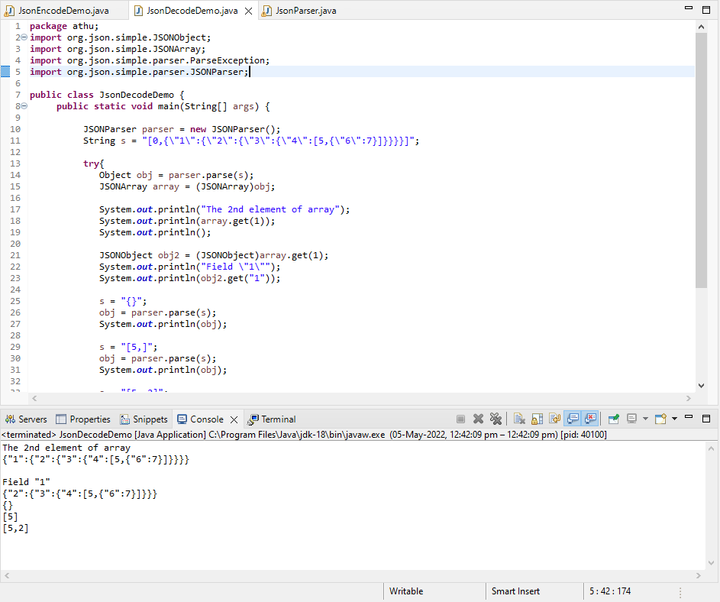

**3.Parsing:**

package athu;

import org.json.simple.JSONObject;

import org.json.simple.parser.JSONParser;

import org.json.simple.parser.ParseException;

import java.io.FileReader;

import java.io.IOException;

import java.io.Reader;

import java.util.Iterator;

public class JsonParser {

public static void main(String[] args) {

JSONParser parser = new JSONParser();

try (Reader reader = new FileReader("E:\\test.json")) {

JSONObject jsonObject = (JSONObject) parser.parse(reader);

System.out.println(jsonObject);

String name = (String) jsonObject.get("Name");

System.out.println(name);

long num = (Long) jsonObject.get("number");

System.out.println(num);

Double bal = (Double) jsonObject.get("balance");

System.out.println(bal);

Double sal = (Double) jsonObject.get("salary");

System.out.println(sal);

Boolean answer = (Boolean) jsonObject.get("is_intern");

System.out.println(answer);

}

catch (IOException e) {

e.printStackTrace();

}

catch (ParseException e) {

e.printStackTrace();

}

}

}

